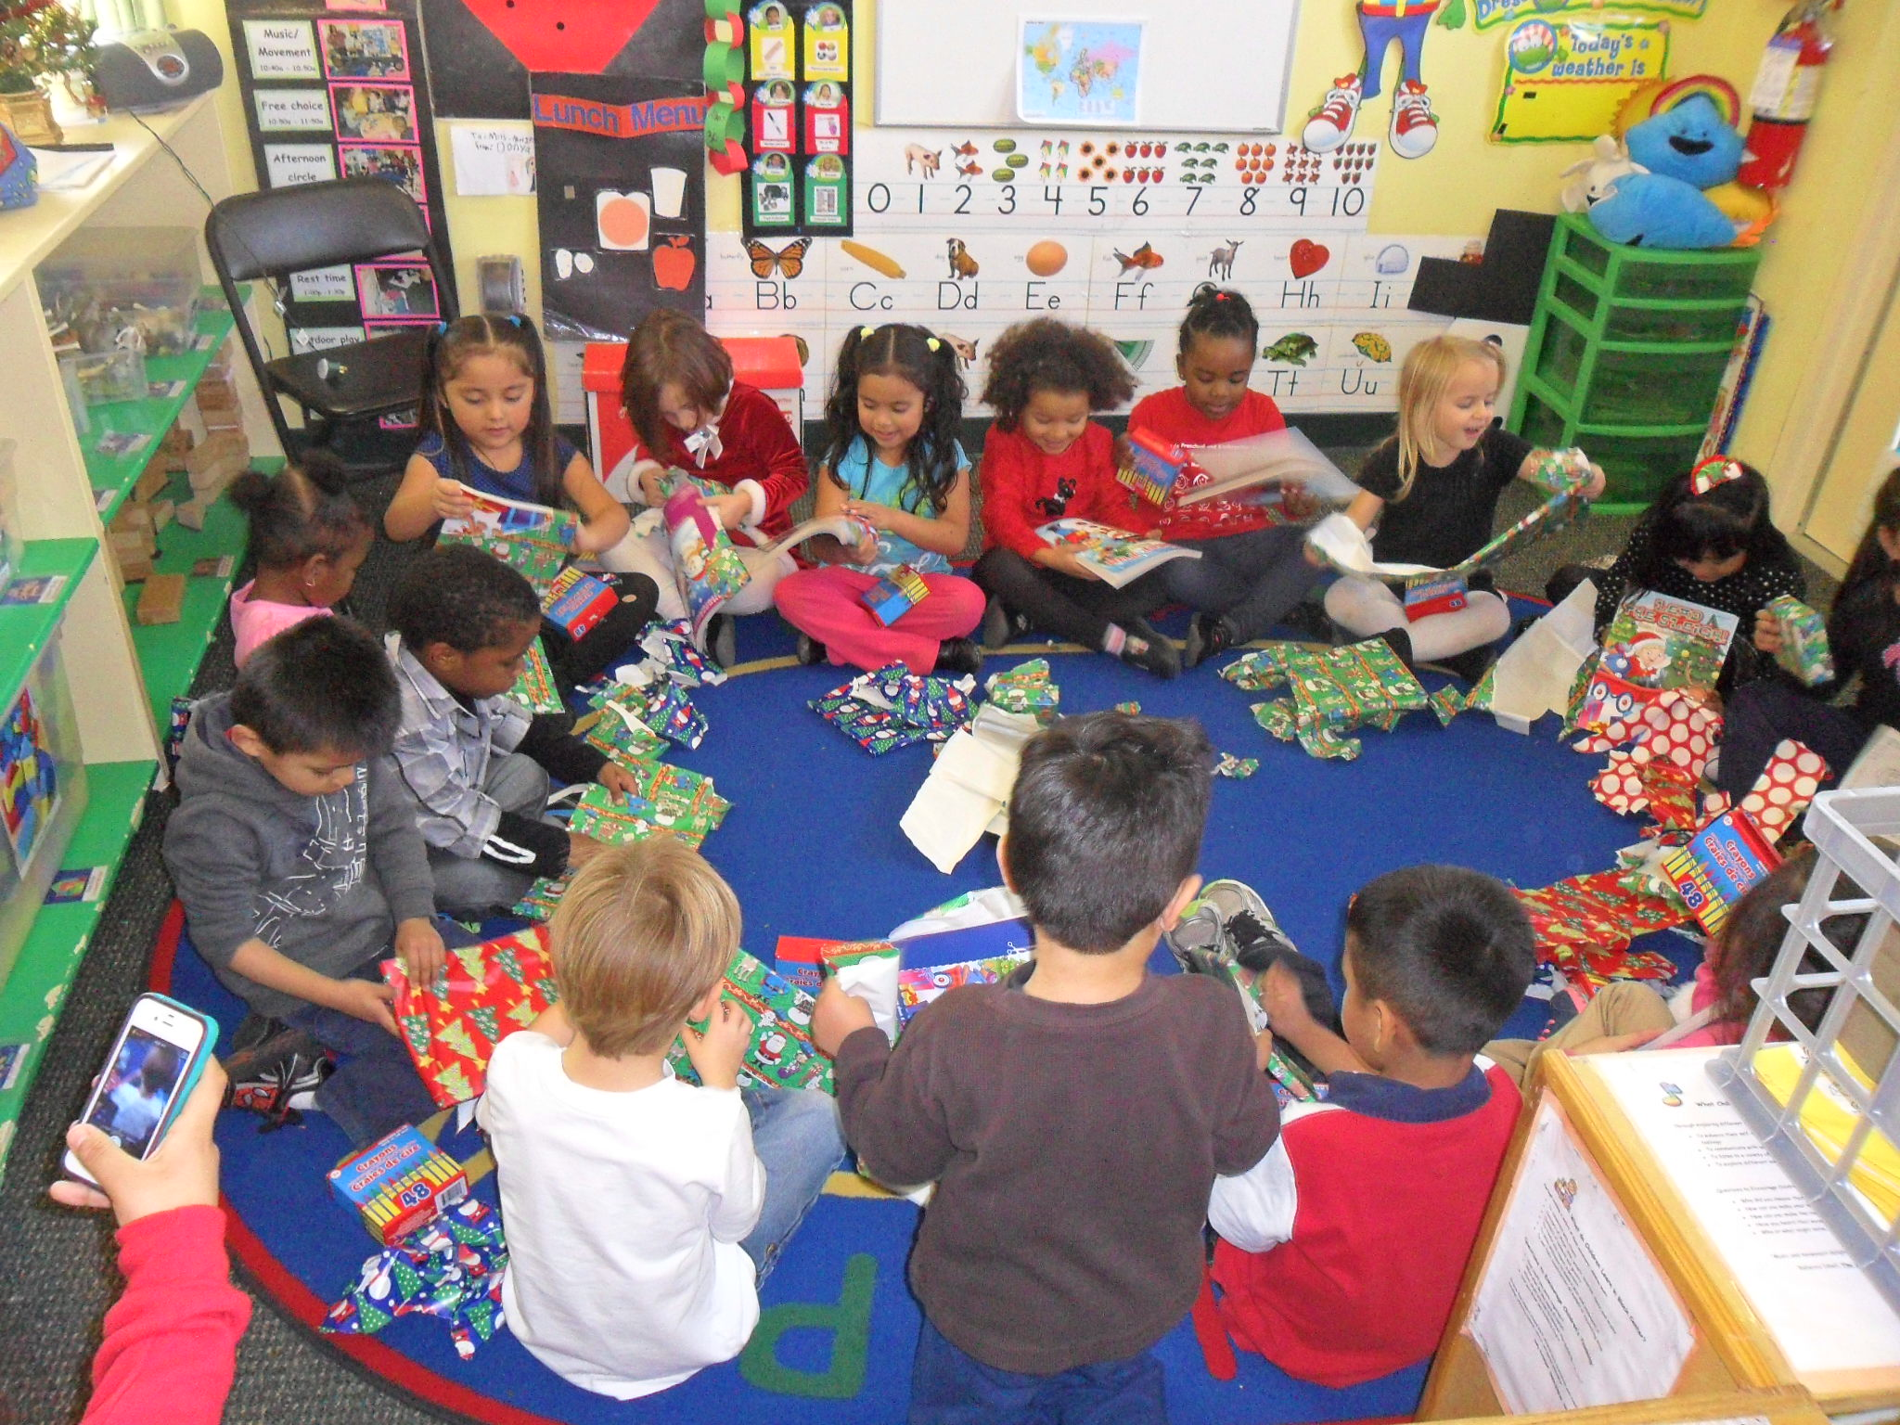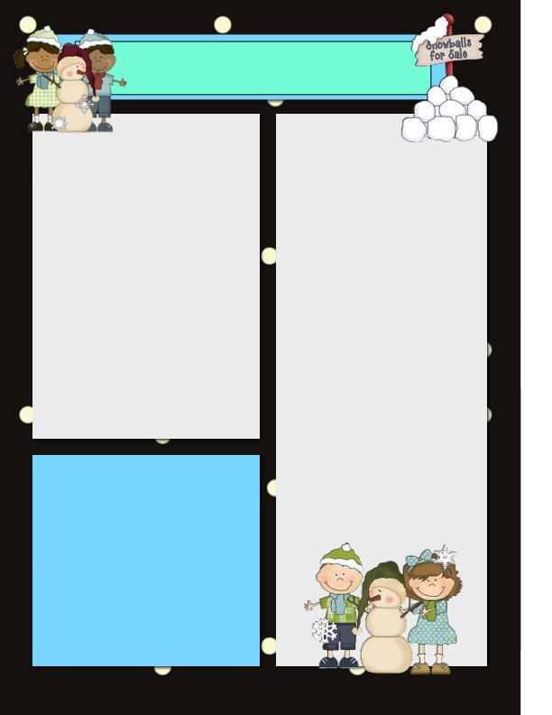

January

Fantastic Frogs Classroom

Dates to Remember

January 7th: Winter Weather Science Rotations

January 13th: PTA Meeting at 6:00 pm in K-1 Classroom

January 19th: Martin Luther Kind Jr. Day/ **No School!**

January 20th: Parent-Teacher Conferences. **No Regular Classes!**

**Birthday Extravaganza**

My birthday was extra special on the 18th when I was surprised with gifts, homemade cards & a surprise party at the end of the day (with mini cupcakes & snacks). Thank you to all who made it possible because it was much appreciated! I could not have thought of a better way to celebrate it than with my fantastic frogs children :)

**Holiday Party on December 19th**

Thank you to all of the parents who helped out with the Holiday Party!! It was a huge success and I believe the children loved every game that they played, enjoyed meeting Santa & enjoyed the snacks! :) It’s always so sweet seeing their faces light up & their excitement! Ms. Rosie & I also would like to give a thank you for all the gifts we received because they were very sweet and thoughtful! We hope you all had a wonderful Holiday & A Happy New Year!! Let’s continue to make memories in 2015!

Blah, blah, blah, blah, blah, blah, blah, blah, blah, blah, blah, blah, blah, blah, blah, blah, blah, blah, blah, blah, blah, blah, blah, blah, blah, blah, blah, blah, blah, blah, blah, blah, blah.

Gifts From Santa

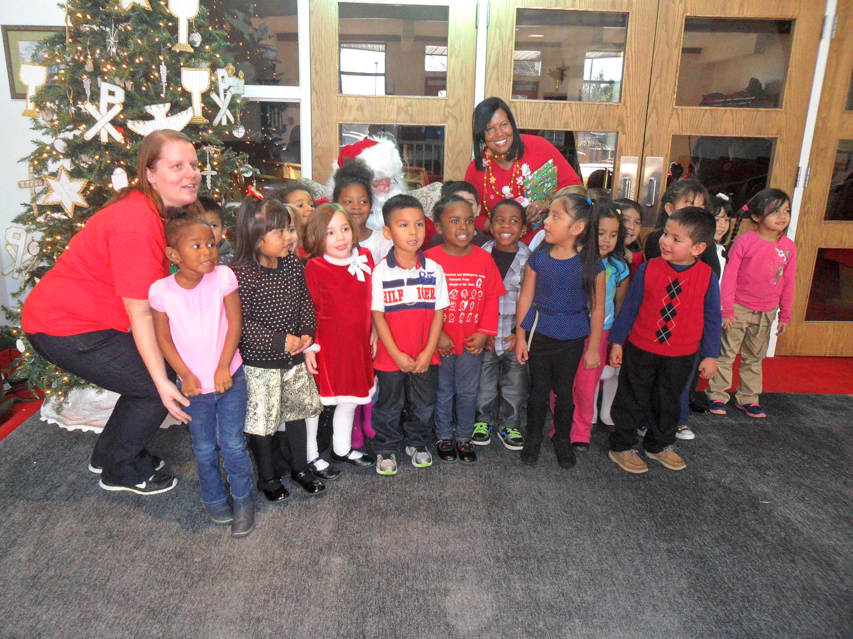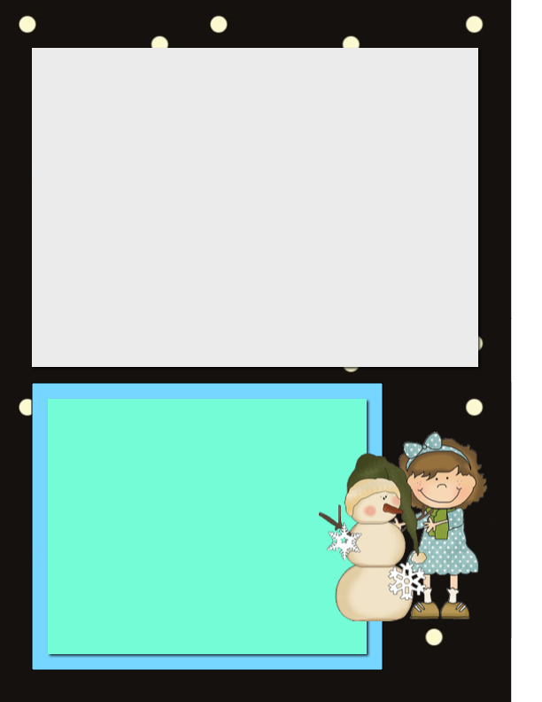

Parent-Teacher Conferences

Tuesday January 20th

(sign-up sheet)

Parent-Teacher Conferences will be held in 40 minute intervals throughout the day of January 20th. We will **NOT** have regular school on this day just conferences. Please see the sign-up sheet on the front table to sign-up for a time that works for your schedule.

ATTENTION!! IMPORTANT!

We want to keep each of your children safe and healthy as we teach them. In order to do this we ask that items that say “Keep Out Of The Reach Of Children” are left at home. If your child needs an item such as chapstick, lotion, hand sanitizer, etc. Please let us know and we can figure out a way to possibly use these items (teachers assistance) with a doctors note. Otherwise these items need to stay at home or in the vehicles. Thank You!

Winter Weather/Delays/Closings

Winter is now in full swing which means that we could have winter weather such as snow. Therefore please keep an eye on the weather and check WRAL, school website and the school’s voicemail for closings or delays. We want to keep everyone safe during these times so keep an eye on these areas to see if we are delayed/closed or closing early.

Also since the weather is changing please be sure to bring your child dressed for the cold weather. Gloves, hats, scarves, layers, etc. to keep them warm outside. Thank You!



Fantastic Frogs with Santa